1. **Subject: Report on STEM Day Excel Analytics Initiative**

Date: 13-nov-2023

To: Vineet Kumar

From: Reena Bala

Subject: STEM Day Excel Analytics Initiative Report

**Introduction:**

On 13 November 2023, in celebration of STEM Day, we organized an initiative to enhance students' analytical skills by teaching them how to create an Excel sheet for predictive modeling from an analytics perspective.

**Objective:**

The main objective of this initiative was to introduce students to the fundamentals of analytics and equip them with the skills to develop prediction models using Excel.

**Details of Activity:**

In this Activity, Students create Excel Sheets With Different data like sales of a company and population of a country they analysis the data and make prediction by using forecast function. They make forecast sheets also with interactive charts.

Also they make Prediction Form by using VBA. This enhances their skills of data analysis and Prediction.

**Results:**

The initiative received enthusiastic participation from the students, and a significant number of them actively engaged in the activities. As a result:

20 students successfully created Excel sheets for predictive modeling.

8 prediction models form were developed and analyzed by the students.

Here is the link of excel sheet of some students:

Student Name –Pooja

<https://docs.google.com/spreadsheets/d/1pK8FL3YG6vjMCVqduYswKgecMGMDIcKk/edit?usp=sharing&ouid=107628572994791756175&rtpof=true&sd=true>

Student Name- Himanshu

<https://docs.google.com/spreadsheets/d/1t0XsUkmdoxYsiIaFjXRFx1HuoOI9E3Kp/edit?usp=sharing&ouid=107628572994791756175&rtpof=true&sd=true>

Student Name- Rinku

<https://docs.google.com/spreadsheets/d/1wUWk-wvLyFEsGsWmtHmAlrI8mZOM0COR/edit?usp=sharing&ouid=107628572994791756175&rtpof=true&sd=true>

Student Name- Neelu Kumari

<https://docs.google.com/spreadsheets/d/1-PZc9SJqz8QLsRsXUU-dsSGa0h3JueNY/edit?usp=sharing&ouid=107628572994791756175&rtpof=true&sd=true>

**Feedback:**

The feedback from the students was highly positive. They found the hands-on approach to be immensely beneficial in solidifying their understanding of analytics and predictive modeling. Many students expressed interest in further exploring analytics tools and techniques.

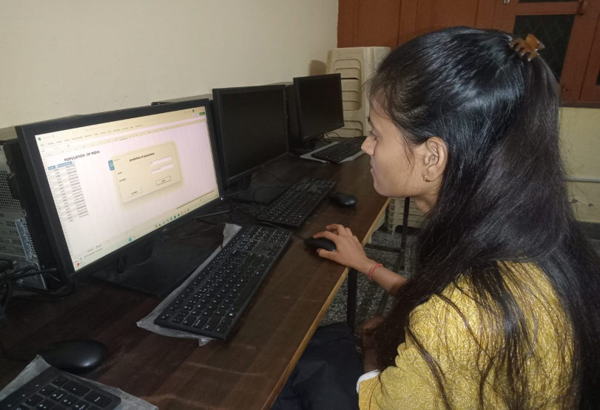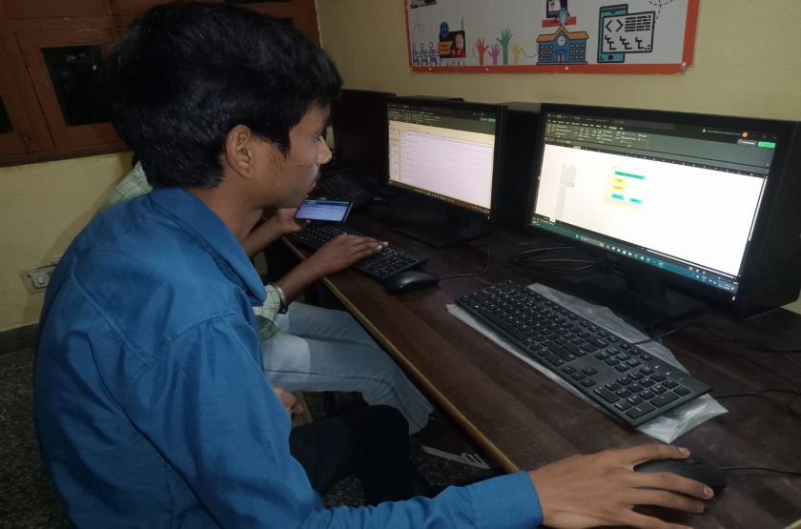Photo:

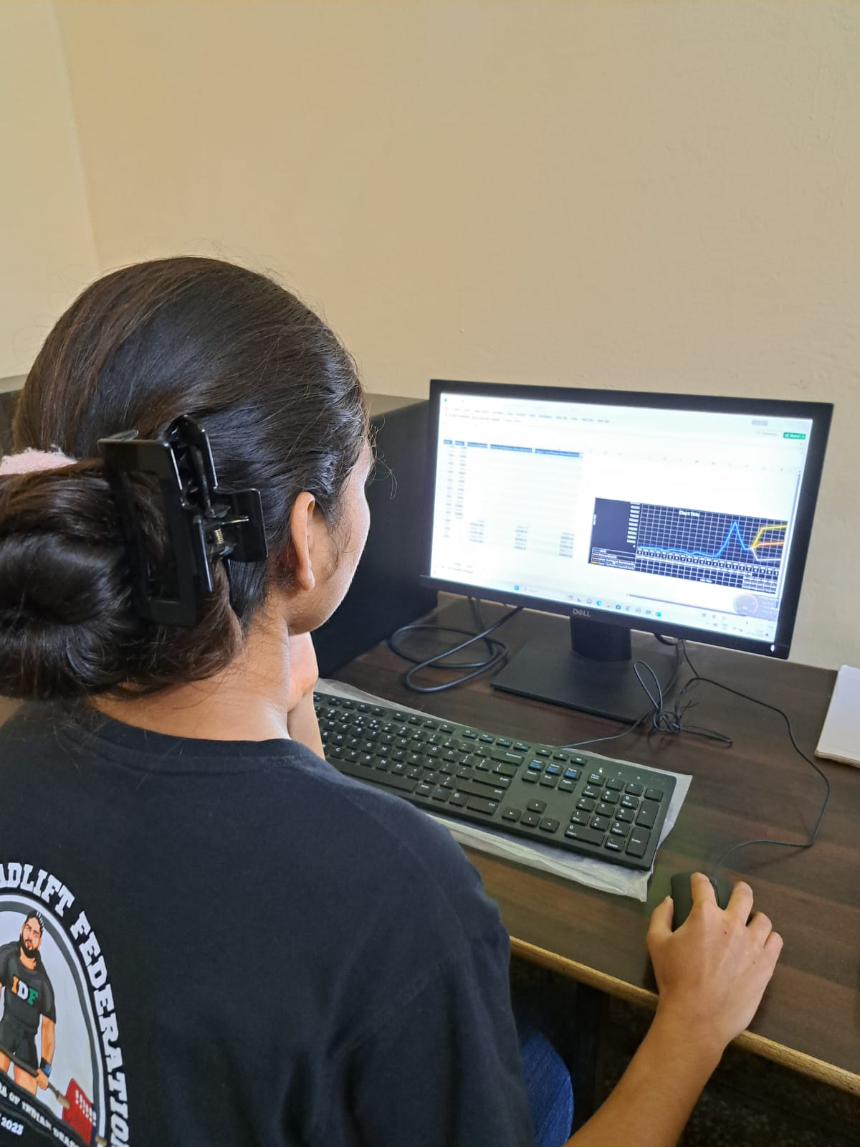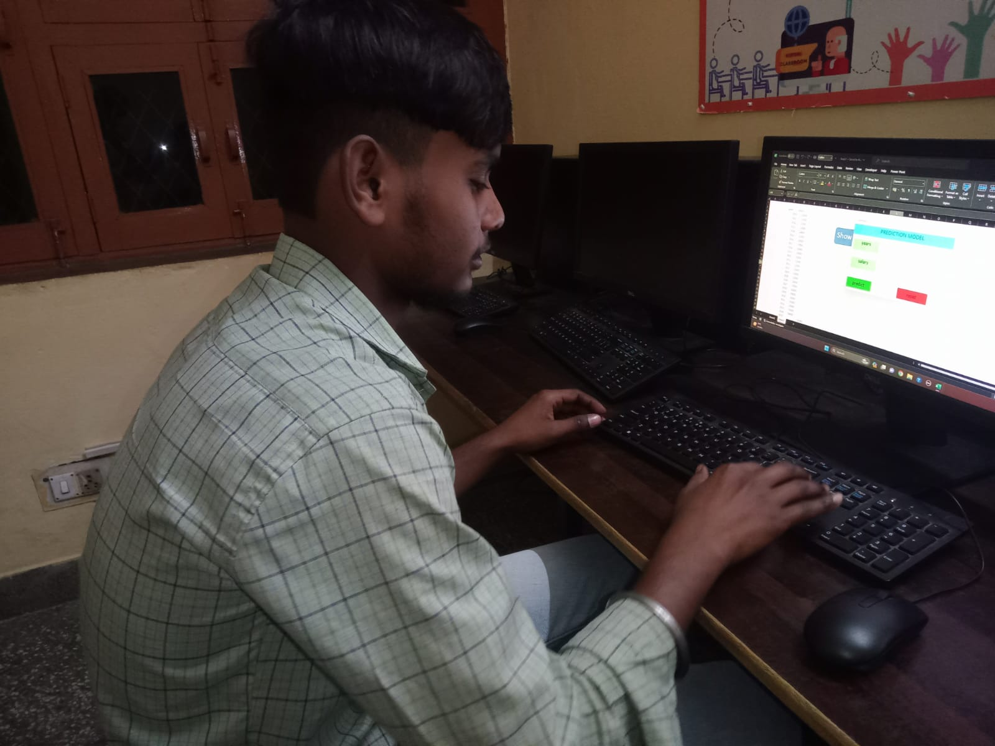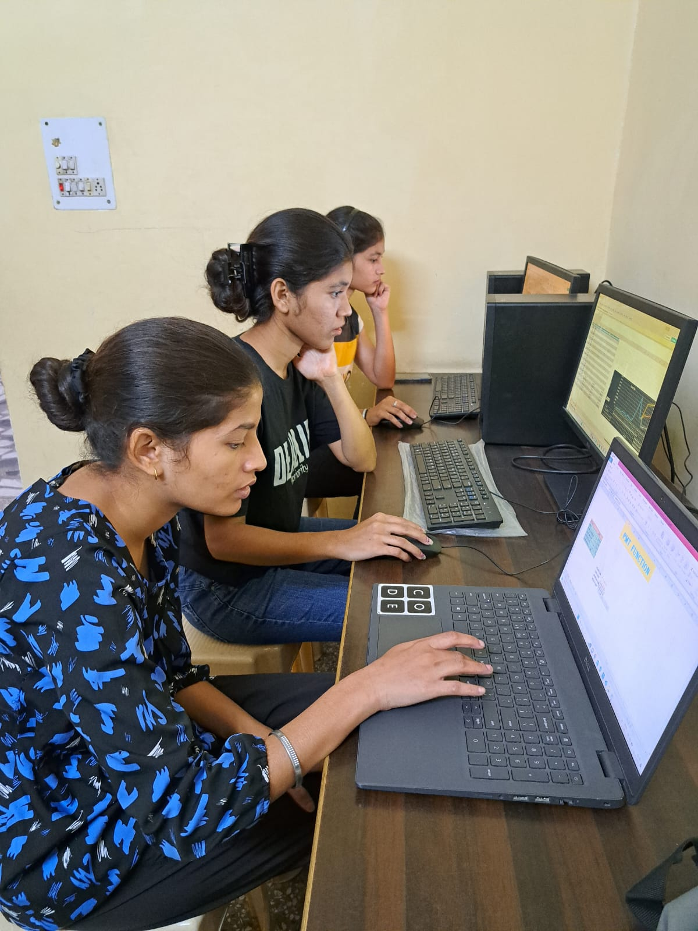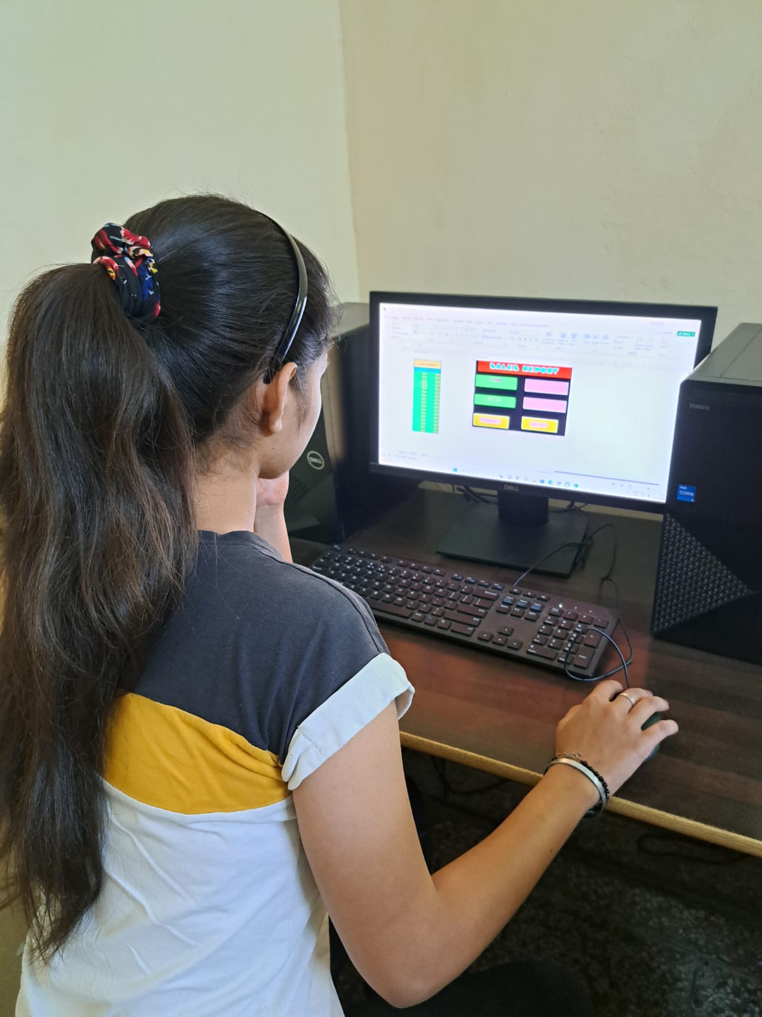

**2. Subject: Report on World Communication Day GitHub Initiative**

Date: 09-Nov-2023

To: Vineet Kumar

From: Reena Bala

Subject: World Communication Day GitHub Initiative Report

**Introduction:**

On 9-nov- 2023 in celebration of World Communication Day, we organized an initiative to encourage our students to create accounts on GitHub, share their projects, and understand the various benefits associated with this platform.

**Objective:**

The main objective of this initiative was to promote effective communication, collaboration, and knowledge sharing among our students by leveraging the capabilities of GitHub.

**Project Showcasing:**

Students were encouraged to share their existing projects or create new ones to showcase on GitHub. This provided them with an opportunity to receive feedback, collaborate with peers, and gain exposure in the developer community.

**Results:**

The initiative received a positive response from the students, and a significant number of them actively participated in the activities. As a result:

10 students created GitHub accounts.

10 projects were uploaded and shared on GitHub.

<https://github.com/Reena-bala/Student/blob/main/new%20pridiction.xlsx>

<https://github.com/RinkuSingh76/rinku1/blob/main/predictionchart.xlsm>

<https://github.com/omkumarn/mr.om./blob/main/psycho0.xlsm>

<https://github.com/Rakhi001yadav/rakhi/commit/efeca416c0d08c469f9a325e7985480d2b4d113c>

<https://github.com/neelumaurya/prediction-model/commit/2f2debf2bec8b4c2c2c42e7244f3c1a596ed0551>

